

**Faculty of Engineering & Technology**

**Electrical & Computer Engineering Department**

**Computer Design Lab ENCS4110**

**Report #3**

**Experiment #10 - DC Motors and PWM**

**Prepared by:**

Rama Abdlrahman -1191344

**Instructor**: Dr. Ahmad Afaneh  
**Assistant**: Eng. Heba Qadah

**Section:** 2

**BIRZEIT**

**June–2022**

# ABSTRACT

The aim of this experiment is to control the speed of a DC motor using Pulse Width Modulation (PWM) and H-Bridge. A driving circuit is required to drive the motor because DC motors need high current and transistors can be used for it. Arduino will also be used to generate PWM signal to drive the DC motor with different speeds.

**Table of Contents**

ABSTRACT 2

1 Theory: 1

1.1 Arduino: 1

1.2 Breadboard 1

1.3 DC-Motor: 2

1.4 Wires: 3

1.5 BJT, NPN Transistor (2N2222): 3

1.6 Diode (1N4001): 3

1.7 Resistors : 4

1.8 H-Bridge L298: 4

2 Procedure and Discussion: 6

2.1 Part1: Use a transistor the control the speed of a DC-Motor. 6

2.1.1 Task 1 : 7

2.2 Part2: Use H-Bridge to control the speed and direction of a DC-Motor 9

2.2.1 Task 2 : 12

3 Conclusion 14

4 References: 15

5 Appendices 15

5.1 Appendix A 15

5.2 Appendix B 16

List of figures

Figure 1 Arduino 1

Figure 2 breadboard 2

Figure 3 DC Motor 2

Figure 4 wires 3

Figure 5 ( 2N2222) transistor 3

Figure 6 diode 4

Figure 7 Resistors 4

Figure 8 structure of H-bridge 4

Figure 9 part1 circuit in TinkerCad 6

Figure 10 Part_1Code 6

Figure 11 Task1 code solution 8

Figure 12 example(1) 8

Figure 13 example(2) 9

Figure 14 Using H-Bridge to control the speed and direction of a DC-Motor 9

Figure 15 part2 circuit in TinkerCad 10

Figure 16 Part_2Code 10

Figure 17 Task2 code solution 13

# 

# Theory:

At this experiment, several component were used to reach our goal . so , Arduino, Breadboard , DC-Motor , Wires , BJT, NPN Transistor (2N2222) , Diode (1N4001) , Resistors (330 Ohm) and H-Bridge L298 were used.

## Arduino:

## 

The main component used at this experiment is Arduino , it is an open-source platform used for building electronics projects . Arduino consists of two parts : physical part or physical circuit board (microcontroller) and software part -IDE -(integrated development environment ). So, a code ( c++) was needed to be written and uploaded using USB to the physical part of the Arduino‎[1].

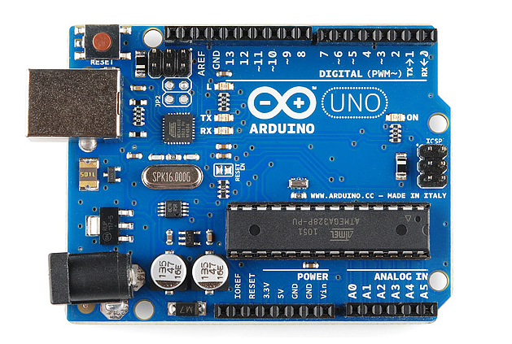

**Figure 1 Arduino**

## Breadboard

Breadboard is a board usually used in electronics projects . it used to insert electronic components like sensor , LED ..etc , the board contains at the top and the button two horizantial lines for positive and negative power connections . and the rest of the board (center part ) for the components‎[1]‎[2] .

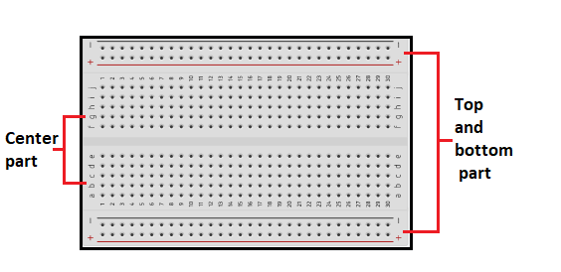

**Figure 2 breadboard**

## DC-Motor:

A DC (Direct Current) motor is a type of electric machine that turns energy from a direct current (electrical energy) into mechanical‎[3].

DC motors draw high currents, so it needs a driving circuit to run the motor. Driving circuits act like a current amplifier, they convert the low current signal to a high current signal. This high current signal is then given to the motor‎[3].

One of the driver circuits used in this experiment is composed of transistors to drive the DC motor.

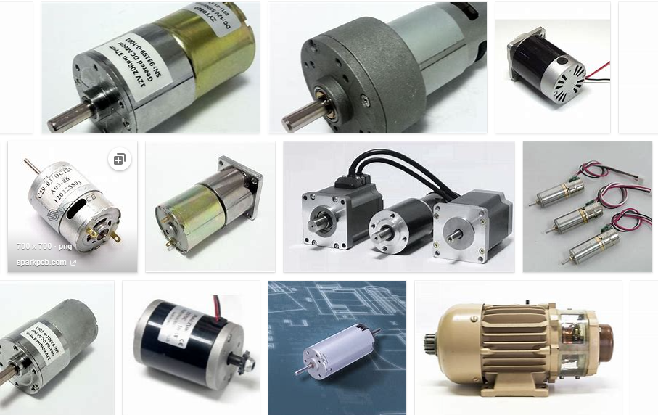

**Figure 3 DC Motor**

## Wires:

## 

Wires are used to connect the components together‎[3].

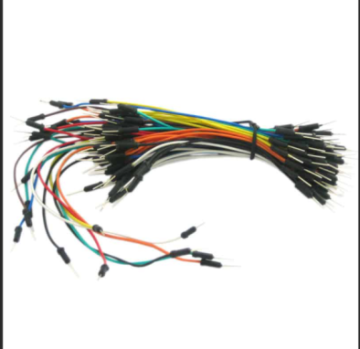

**Figure 4 wires**

## BJT, NPN Transistor (2N2222):

The NPN bipolar junction transistor  2N2222 is one of the important and very commonly used transistor type which finds numerous switching application in electronic circuts. It is most common in the market because of the cost efficiency and the smaller size‎[3]‎[4].

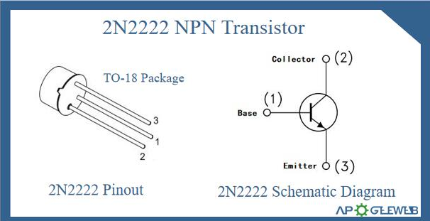

**Figure 5 ( 2N2222) transistor**

## Diode (1N4001):

The main usage of the diode is to transform AC to DC , in addition , to protect the circuit by controlled or limiting the voltage . most of the diode made from silicon or germanium "semiconductors " . there is a lot of types of the diode and for each type there is applications‎[3]‎[4].

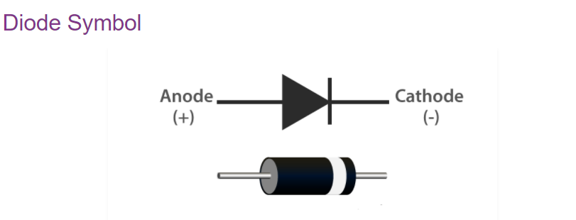

**Figure 6 diode**

## Resistors :

A passive electrical component with two terminals that are used for either limiting or regulating the flow of electric current in electrical circuits. **\*.** It used to save the devices from damage because of the large current **.** there is two types of resistors , linear and non linear and its unit is (ohm)‎[3] .

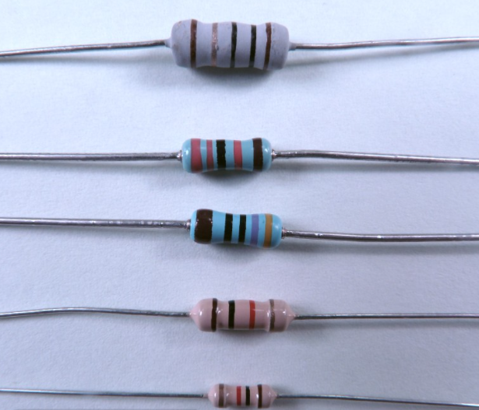

**Figure 7 Resistors**

## H-Bridge L298:

H bridge circuit is a motor driver circuit used to control both of the speed and direction of the motor. The name H Bridge is used because of the diagrammatic representation of the circuit‎[3].

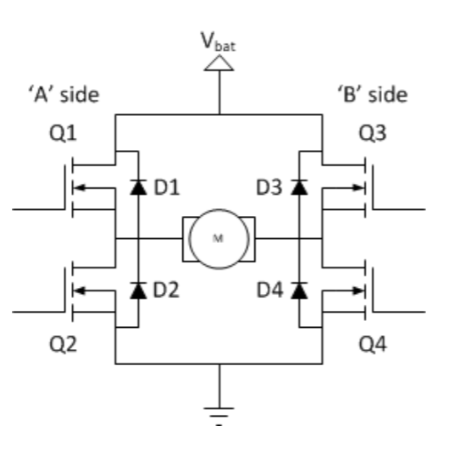Usually, the H bridge circuit contains 4 switches Q1, Q2, Q3 and Q4. The basic structure of H-bridge circuit is shown in the figure below‎[3]‎[4].

**Figure 8 structure of H-bridge**

If Q1 and Q4 are ON while Q2 and Q3 are OFF, the motor can run clockwise(forward direction).

If Q2 and Q3 are ON while Q1 and Q4 are OFF, the motor is going to reverse the direction(run counter-clockwise /backward direction)‎[4].

# Procedure and Discussion:

## Part1: Use a transistor the control the speed of a DC-Motor.

The circuit was connected as shown in the figure below, such that one port of the motor is connected to a diode and a +5V and the other port is connected to a transistor which is connected to a resistor and the ground.

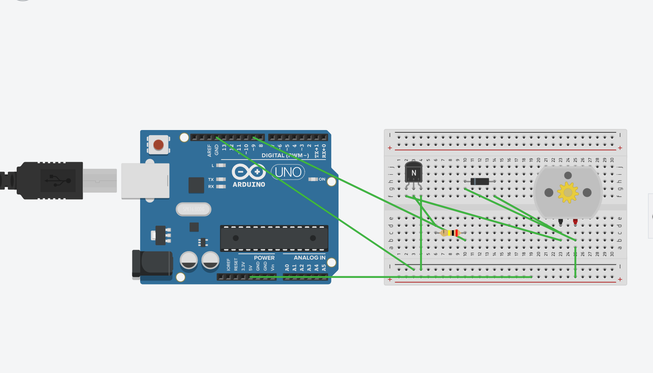

**Figure 9 part1 circuit in TinkerCad**

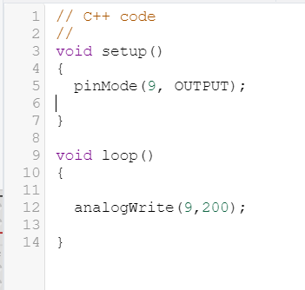

Figure 10 Part_1Code

In this part, the digital pin 9 from the Arduino was connected to the base of transistor (and the resistor) and in TinkerCad we wrote the code that is shown in appendix A.

After running the code, we noticed that the motor started working at approximately 792rpm.Then we tried changing “digitalWrite (9, HIGH);” to “digitalWrite (9, LOW);” and after running the code we noticed that the motor stopped working. The explanation for this is that we are giving the pin 9 a digital value so when we gave it a HIGH value it’s equivalent to 255 so the motor is expected to work at it’s highest speed and when we gave it LOW value it’s equivalent to 0 so the motor is expected to not work.

Then we tried writing analog values directly to pin 9. We started by trying “analogWrite (9,200);” and the result is that the motor worked with a speed between 602rpm up to 634rpm.

Then we tried “analogWrite (9,64);” and after running the code the motor worked with a speed between 178rpm up to 213rpm. And the duty cycle for this trial was 25% (= 64/255).

### Task 1 :

Using Serial monitor, write a code to read a number from keyboard and change the speed of the motor. You have to check if the number between 0 and 255. Print an error message if the number outside this range. Show the result to the instructor.

Here in the task, we want to control the speed of the motor by taking analog values to write on pin9 from the user (Serial monitor) with checking if the number entered is within the valid range. The code is in the figure below.

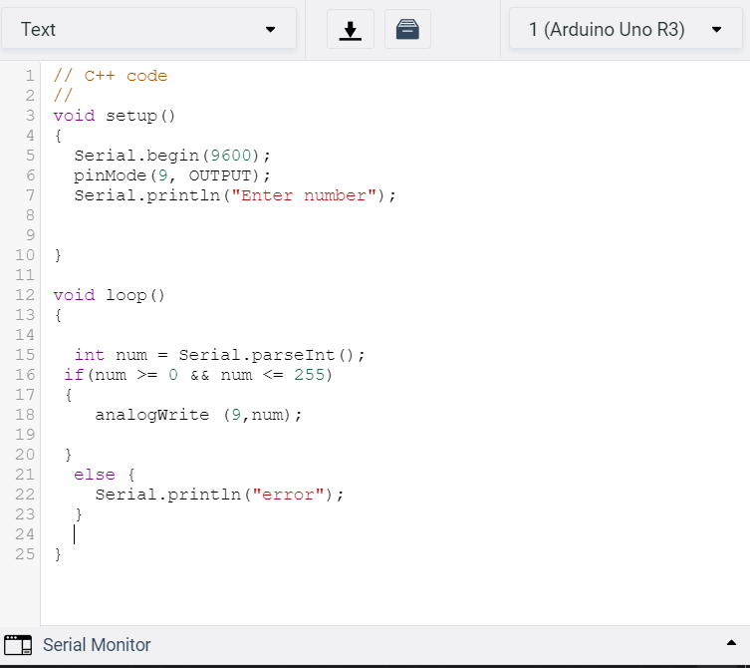

**Figure 11 Task1 code solution**

And the result as the question asked , to control the speed of the DC motor , if the number entered is between 0 and 255 , the speed increase or decrease depends on the number we entered , but if we entered another number , error massage will shown .

The figure below will shown the result of running the code when entered ( 1111) :

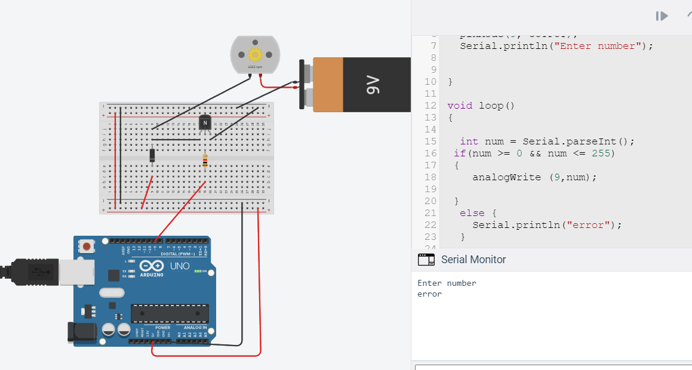

**Figure 12 example(1)**

The figure below will shown the result of running the code if we entered (222):

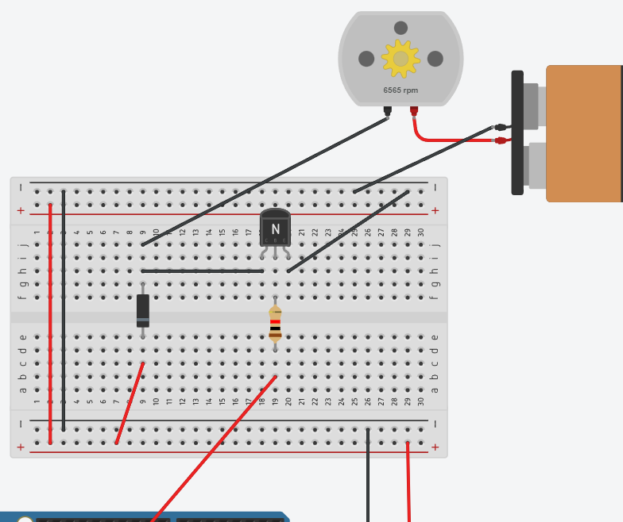

**Figure 13 example(2)**

## Part2: Use H-Bridge to control the speed and direction of a DC-Motor

In this part, we want to control the speed and also the direction of the dc motor using h-driver. We connected the circuit in the figure below.

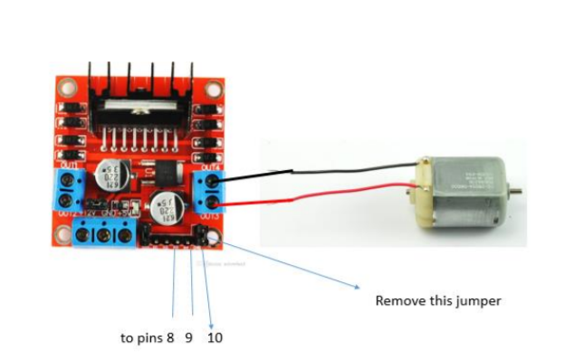

**Figure 14 Using H-Bridge to control the speed and direction of a DC-Motor**

The circuit after connection in TinkerCad is shown in the figure below.

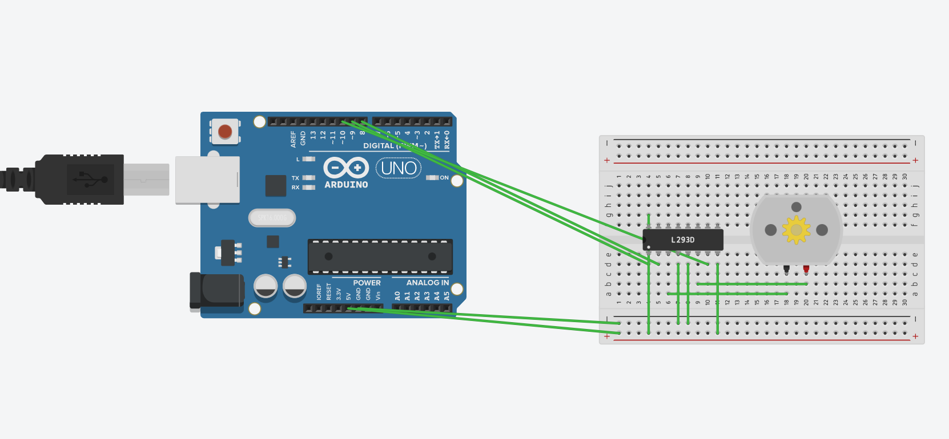

**Figure 15 part2 circuit in TinkerCad**

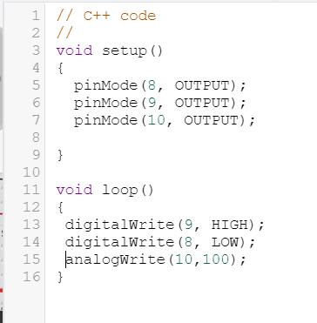

Figure 16 Part_2Code

Then we wrote the code that is shown in appendix B , such that pin 9 acts like an enable so when it’s value is 0 (LOW) the motor doesn’t work and when it’s 1(HIGH) the motor works depending in the other pins values. Pin 8 and 10 are inputs to the circuit.

First, we tried when pin#9 is 0, pin#8 is 1 and pin#10 generates duty cycle 100% which means that it has an analog value of 255 (=100%*255). So, the code was:

digitalWrite(9, LOW);

digitalWrite(8, HIGH);

analogWrite(10, 255);

The result was that the motor did not work and that’s because pin 9 which is the enable of the circuit has a value of 0 (low state).

Then we tried to change pin#9 to 1, pin#8 is 0. So, the code became:

digitalWrite(9, HIGH);

digitalWrite(8, LOW);

analogWrite(10, 255);

The result was that the motor worked with speed of 9393rpm in clock wise (+) direction. And that’s because pin 9 which is the enable of the circuit has a value of 1 (high state) and pin8 which controls the direction has a value of 0(low state).

Then we tried to change the duty cycle at pin#10 to 50% which means pin 10 will have the analog value of 128 (= 50%*255). So, the code became:

digitalWrite(9, HIGH);

digitalWrite(8, LOW);

analogWrite(10, 128);

The result was that the motor worked with an approximately speed of 4500rpm in clock wise (+) direction. And that’s because pin 9 which is the enable of the circuit has a value of 1 (high state) and pin8 which controls the direction has a value of 0 (low state).

In general, in this circuit the pins work as follow:

Pin9 is an enable. When it’s in a high state the circuit works depending on other pins values and if its in a low state the circuit does not work regardless of other pins values.

Pin8 is an input which controls the direction for the motion of the motor. When it’s in a high state the motor works in the clockwise (+) direction and if it’s in a low state the motor works in a counter-clockwise (-) direction.

Pin10 is an input which controls the speed for the motion of the motor depending on the analog value that is given to it which ranges between 0 and 255.

The task below will show how exactly control the direction of the DC motor .

### Task 2 :

Write code such that you can control the direction and speed of a DC-Motor from the keyboard. Show the result to the instructor.

This task has the same idea of part2. The only difference here is that the value and the direction for the motor speed are taken from the user by the serial monitor.

The code is shown in the figure below.

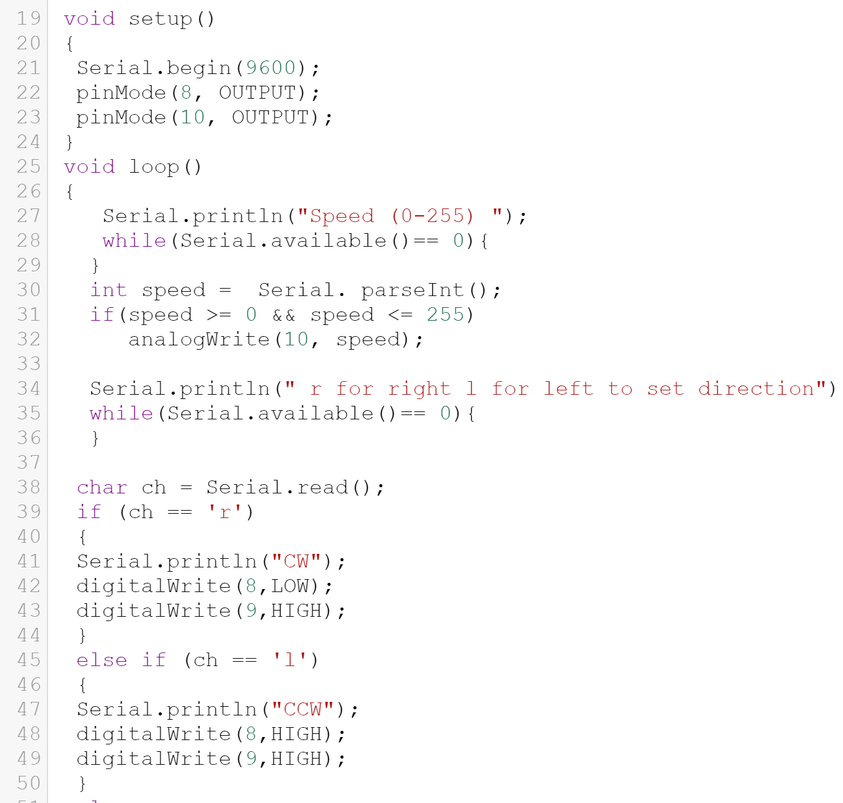

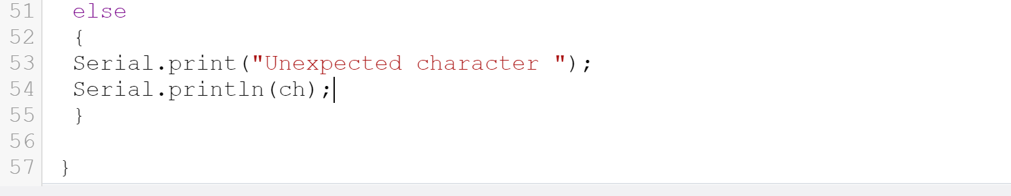

**Figure 17 Task2 code solution**

And the result as the question asked , to control the direction and the speed of the DC motor , if the number entered is between 0 and 255 , the speed increase or decrease depends on the number we entered , but if we entered another number , error massage will shown , also , if we enter (F) > FORWARD , the direction will be positive , else if the number = 'B' > BACKWARD, the direction will reverse .

# Conclusion

In this experiment we learnt how to control and change the speed of a dc motor using PWD. We can change the speed of it by using a transistor with a diode and resistance connected to the digital pin 9 of the Arduino (as shown previously) with a written code to control the status of pin9 which will determine the speed of the motor.

The speed and direction of a dc motor can be controlled by using an H-Bridge driving circuit and connecting it with 3 pins from the Arduino which are pin 8,9 and 10. One of these pins is used as an enable to the circuit(motor), another one is used as an input to control the speed of the motor and the last one is used as an input to control the direction to the motor motion. We can change the statuses of the pins to control the motor as wanted.

# References:

1. <https://www.magneticinnovations.com/faq/dc-motor-how-it-works/> Accessed on 16/6/2022 at 4:00pm.

1. <https://www.mepits.com/tutorial/379/electrical/motor-driver/> Accessed on 16/6/2022 at 5:30pm.

1. <https://iopscience.iop.org/article/10.1088/1757-899X/602/1/012017/pdf/> Accessed on 19/6/2022 at 7:15pm.
2. <https://www.mepits.com/tutorial/379/electrical/motor-driver> Accessed on 19/6/2022 at 10:00pm

# Appendices

## Appendix A

Void setup () {

pinMode (9, OUTPUT);

}

Void loop {

digitalWrite (9, HIGH);

}

## Appendix B

void setup()

{

pinMode(10, OUTPUT);

pinMode(9, OUTPUT);

pinMode(8, OUTPUT);

}

void loop()

{

digitalWrite(9, HIGH);

digitalWrite(8, LOW);

analogWrite(10, 128);

}